Project Plan and Meetings
Group Leader: Caleb Clifton
Group Name: Best Group (#1)
Method: Pseudocode
System Architect: Caleb Clifton
Collaboration Tools: Google Spaces (Chat, Meetings, Documents)
Meeting 1 1/31/2026 Voice Attendance: Caleb Clifton, Catherine Ambriole
Meeting 1 1/31/2026 Text Attendance: Ismail Babani, Benjamin Brown
Meeting 2 Text Attendance/Participation: Ismail Babani, Benjamin Brown, Wesley Fox, Catherine Ambriole, Caleb Clifton
2/23/2026 Participation: Caleb Clifton, Ismail Babani, Benjamin Brown, Wesley Fox, Catherine Ambriole
3/6/2026 Participation: Caleb Clifton, Ismail Babani, Benjamin Brown, Wesley Fox, Catherine Ambriole

Johnny Bailey did not respond to emails, Canvas messages, or google chats throughout the semester.

Development Modules:
- Data Entry Module
Objective: Collect all required employee and payroll input data.
  - Prompt the user for employee first and last name, employee ID, number of dependents, and hours worked.
  - Ensure all required fields are collected before passing data to the Security module.
  - Forward collected input data for validation and further processing.
- Pay Calculation Module – Caleb Clifton
Objective: Calculate gross pay, taxes, and net pay according to defined payroll rules.
  - Retrieve the employee’s hourly rate from the database using employee ID as the primary key.
  - Handle missing or invalid pay rate lookups with appropriate error messaging.
  - Calculate gross pay, including regular pay for up to 40 hours and overtime pay at 1.5 times the hourly rate for hours over 40.
  - Calculate taxes based on the pre-tax amount, including state tax at 5.6% and federal tax at 7.9%.
  - Calculate post-tax (net) pay and apply consistent rounding rules.
- Data Output Module – Benjamin Brown
Objective: Record payroll results in a spreadsheet-friendly format.
  - Define required spreadsheet columns for employee information, hours worked, pay rates, gross pay, taxes, and net pay.
  - Output payroll results as a new row in the spreadsheet for each employee.
  - Format numeric and currency values consistently and verify accuracy of recorded data.
- Security Module – Catherine Ambriole
Objective: Protect data integrity and ensure only valid data is processed.
  - Validate all input data received from the Data Entry module, including employee ID format, non-negative dependents, and reasonable hours worked.
  - Enforce validation before allowing database pay rate lookup or payroll calculations.
  - Restrict access to pay rate retrieval logic to validated employee IDs only.
  - Prevent unnecessary exposure of sensitive employee or payroll data.
- Testing and Validation Module - Ismail Babani
Objective: Verify that the payroll program functions correctly under normal and error conditions.
  - Create test cases for standard, overtime, and boundary scenarios.
  - Test invalid inputs such as negative values or invalid employee IDs.
  - Manually verify payroll calculations against expected results.
  - Validate spreadsheet output formatting and data accuracy.
  - Confirm proper interaction between all modules from data entry through output.
  - Testing commencing 2/23/26 after main code is mostly finished

Program Cod
BEGIN PROGRAM

// Variable Definitions
// Constants
SET REG_HOURS = 40
SET OT_MULT = 1.5
SET STATE_TAX_RATE = 0.056
SET FED_TAX_RATE = 0.079

// Input variables
DECLARE firstName
DECLARE lastName
DECLARE employeeID
DECLARE numDependents
DECLARE hoursWorked

// Pay variables
DECLARE hourlyRate
DECLARE regularHours
DECLARE overtimeHours
DECLARE grossPay
DECLARE stateTax
DECLARE federalTax
DECLARE netPay
DECLARE regularPay
DECLARE overtimePay
DECLARE preTaxAmount
DECLARE rateFound

// Logic variables
DECLARE isValid
DECLARE errorMessage
DECLARE endProgram

// MAIN FLOW
REPEAT

CALL DataEntryModule(firstName, lastName, employeeID, numDependents, hoursWorked,
endProgram)

IF endProgram = TRUE THEN
DISPLAY "End of program"
EXIT LOOP
END IF

CALL SecurityModule(firstName, lastName, employeeID, numDependents, hoursWorked, isValid,
errorMessage)

IF isValid = FALSE THEN
DISPLAY errorMessage
ELSE
CALL PayCalculationModule(employeeID, hoursWorked,
hourlyRate, rateFound, regularHours, overtimeHours, regularPay, overtimePay,
grossPay, preTaxAmount, stateTax, federalTax, netPay)

IF rateFound = FALSE THEN
DISPLAY "Employee ID not found. Cannot retrieve hourly rate."
ELSE
CALL DataOutputModule(firstName, lastName, employeeID, numDependents,
hourlyRate, hoursWorked,
regularHours, overtimeHours,
regularPay, overtimePay,
grossPay, stateTax, federalTax, netPay)

END IF
END IF

UNTIL FALSE

// Data Entry Module
BEGIN DataEntryModule(OUT firstName, OUT lastName, OUT employeeID, OUT numDependents, OUT hoursWorked, OUT endProgram)

SET endProgram = FALSE

DO
DISPLAY "Enter employee first name (ZZZ to quit):"
INPUT firstName
WHILE firstName is blank

IF firstName = "ZZZ" THEN
SET endProgram = TRUE
RETURN
END IF

DO
DISPLAY "Enter employee last name:"
INPUT lastName
WHILE lastName is blank

DO
DISPLAY "Enter employee ID:"
INPUT employeeID
WHILE employeeID is blank

DO
DISPLAY "Enter number of dependents:"
INPUT numDependents
WHILE numDependents is blank

DO
DISPLAY "Enter hours worked:"
INPUT hoursWorked
WHILE hoursWorked is blank

END DataEntryModule

BEGIN SecurityModule(firstName, lastName, employeeID, numDependents, hoursWorked, OUT isValid, OUT errorMessage)

SET isValid = TRUE
SET errorMessage = ""

IF firstName is blank OR lastName is blank OR employeeID is blank OR numDependents is blank OR hoursWorked is blank
SET isValid = FALSE
SET errorMessage = "Blank value detected. All values must be entered."
END IF

// Hours worked validation
IF isValid = TRUE
IF hoursWorked is not numeric OR hoursWorked < 1 OR hoursWorked > 80
SET isValid = FALSE
SET errorMessage = "Hours worked must be between 1 and 80."
END IF
END IF

// Dependents validation
IF isValid = TRUE
IF numDependents is not numeric OR numDependents < 0 OR numDependents >10
SET isValid = FALSE
SET errorMessage = "Number of dependents must be between 0 and 10."
END IF
END IF

// Employee ID validation
IF isValid = TRUE
IF employeeID is not numeric OR length(employeeID) != 6
SET isValid = FALSE
SET errorMessage = "Employee ID is 6 digits long"
END IF
END IF

// First name validation
IF isValid = TRUE
IF firstName is not string OR length(firstName) < 2 OR length(firstName) > 20
SET isValid = FALSE
SET errorMessage = "That is not a valid first name."
END IF
END IF

// Last name validation
IF isValid = TRUE
IF lastName is not string OR length(lastName) < 2 OR length(lastName) > 20
SET isValid = FALSE
SET errorMessage = "That is not a valid last name."
END IF
END IF

END SecurityModule

BEGIN GetHourlyRateFromDatabase(employeeID, OUT hourlyRate, OUT rateFound)

SET rateFound = FALSE
SET hourlyRate = 0

IF employeeID exists in EmployeeTable THEN
SET hourlyRate = EmployeeTable.hourlyRate for employeeID
SET rateFound = TRUE
END IF

END GetHourlyRateFromDatabase

BEGIN PayCalculationModule(employeeID, hoursWorked,
OUT hourlyRate, OUT rateFound,
OUT regularHours, OUT overtimeHours,
OUT regularPay, OUT overtimePay,
OUT grossPay, OUT preTaxAmount,
OUT stateTax, OUT federalTax, OUT netPay)

// Get hourly rate from database
CALL GetHourlyRateFromDatabase(employeeID, hourlyRate, rateFound)

IF rateFound = FALSE THEN
RETURN
END IF

// Split regular and overtime hours
IF hoursWorked <= REG_HOURS THEN
SET regularHours = hoursWorked
SET overtimeHours = 0
ELSE
SET overtimeHours = hoursWorked - REG_HOURS
SET regularHours = REG_HOURS
END IF

// Calculate gross pay and pre-tax amount
SET regularPay = regularHours * hourlyRate
SET overtimePay = overtimeHours * (hourlyRate * OT_MULT)
SET grossPay = regularPay + overtimePay
SET preTaxAmount = grossPay

// Calculate taxes (State and Fed) and Net Pay
SET stateTax = preTaxAmount * STATE_TAX_RATE
SET federalTax = preTaxAmount * FED_TAX_RATE
SET netPay = preTaxAmount - stateTax - federalTax

// Round monetary values to 2 digits
SET regularPay = ROUND(regularPay, 2)
SET overtimePay = ROUND(overtimePay, 2)
SET grossPay = ROUND(grossPay, 2)
SET stateTax = ROUND(stateTax, 2)
SET federalTax = ROUND(federalTax, 2)
SET netPay = ROUND(netPay, 2)

END PayCalculationModule

// Data Output Module
BEGIN DataOutputModule(firstName, lastName, employeeID, numDependents,
hourlyRate, hoursWorked,
regularHours, overtimeHours,
regularPay, overtimePay,
grossPay, stateTax, federalTax, netPay)

DISPLAY "EMPLOYEE PAY REPORT"
DISPLAY "Employee name: " firstName, " " lastName
DISPLAY "Employee ID: " employeeID
DISPLAY "Number of Dependents: " numDependents
DISPLAY "Hourly Rate: $" , hourlyRate
DISPLAY "Hours Worked: ", hoursWorked
DISPLAY "Regular Hours: ", regularHours
DISPLAY "Overtime Hours: ", overtimeHours
DISPLAY "Regular Pay: $ " , regularPay
DISPLAY "Overtime Pay: $" , overtimePay
DISPLAY "Gross Pay: $ ", grossPay
DISPLAY "State Tax (5.6%): $" stateTax
DISPLAY "Federal Tax (7.9%): $" federalTax
DISPLAY "Net Pay : $ " , netPay

APPEND ROW to PayrollReport: firstName, lastName, employeeID, numDependents,
hoursWorked, hourlyRate, regularPay, overtimePay, grossPay, stateTax, federalTax, netPay
END DataOutputModule

END PROGRAM

Program Unit Testing

Testing and Debugging for the Payroll System
- Ismail Babani
My assigned responsibility in the group project was Testing and Debugging. While other team members developed the Security Module, Database Module, and Payroll Calculation Module, my task was to:
- Design the testing strategy
- Create unit tests for each module
- Perform integration testing
- Conduct manual testing
- Document all test results
- Identify and debug issues
- Provide evidence that the payroll system works correctly
This section reflects my individual contribution to the final project.

Testing Strategy

The payroll system was tested using three complementary methods:
- Unit Testing – Testing each module independently
- Integration Testing – Testing the full workflow from input → validation → database → calculation
- Manual Testing – Running the program and capturing screenshots of real outputs
This multi‑layered approach ensures that each component works correctly on its own and as part of the complete system.

Unit Testing (pytest)

I created a dedicated test file named test_payroll.py to verify the behavior of the SecurityModule and PayCalculationModule.

Unit Test File

from final_project import SecurityModule, PayCalculationModule

def test_valid_employee():
valid, msg = SecurityModule("James", "Carter", "102483", 2, 45)
assert valid

def test_invalid_hours():
valid, msg = SecurityModule("Maria", "Lopez", "348719", 1, 100)
assert not valid

def test_invalid_id():
valid, msg = SecurityModule("Daniel", "Hughes", "7712", 3, 40)
assert not valid

def test_employee_not_found():
result, found = PayCalculationModule("999999", 40)
assert not found

def test_invalid_first_name():
valid, msg = SecurityModule("A", "Fields", "660347", 2, 40)
assert not valid
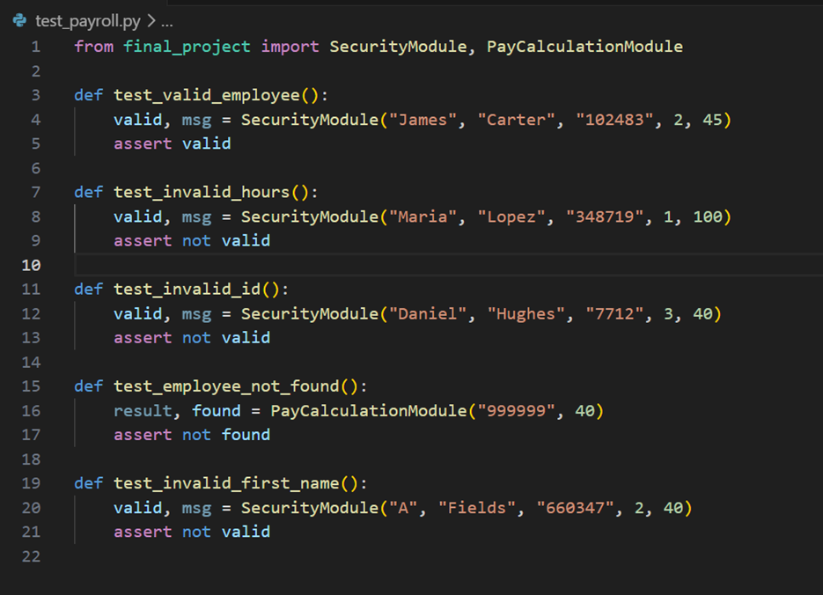

What These Tests Cover
- Name validation
- ID validation
- Hours validation
- Employee lookup
- Payroll calculation behavior
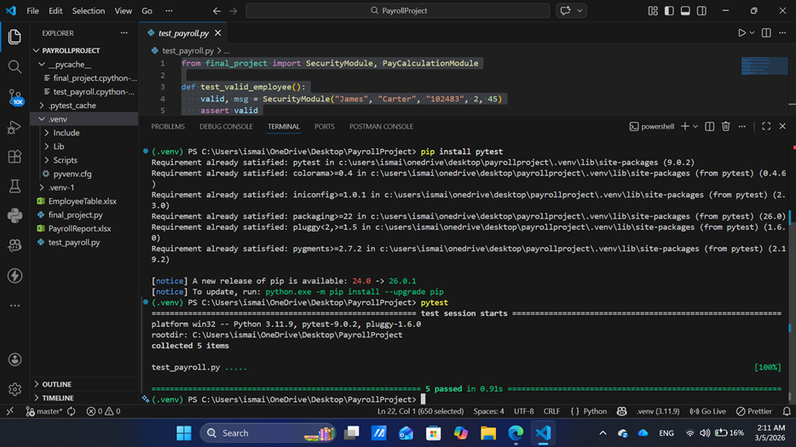

Integration Testing

Integration testing verifies that the entire payroll workflow functions correctly:
- Validate input
- Retrieve hourly rate from Excel
- Calculate gross pay, taxes, and net pay
- Output results
The integration tests were executed using the run_test() function inside final_project.py.

Integration Test Scenarios

- Valid employee with overtime
- Invalid hours
- Invalid employee ID
- Invalid first name
- Employee not found in database
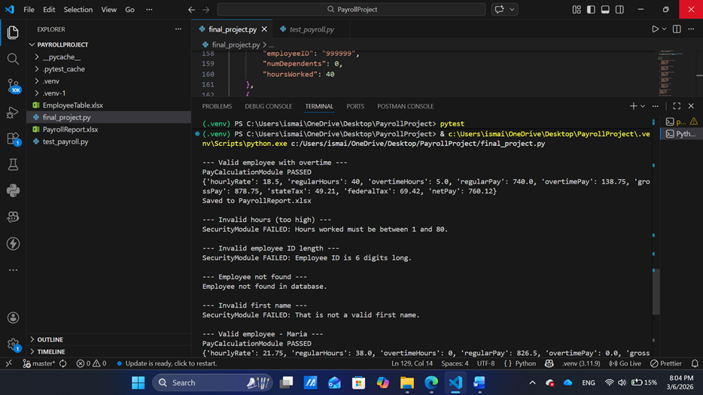

Excel Output Verification

As part of integration testing, the system was required to record payroll results into PayrollReport.xlsx. After running the full test suite, the program successfully wrote the payroll results for the valid employee test case. Invalid test cases (bad name, bad ID, invalid hours, employee not found) were correctly not written to the spreadsheet.

Manual Testing Procedure
To perform manual testing, I executed the payroll program using the predefined test cases stored in the test_cases list. Each test case represents a different scenario, including valid input, invalid hours, invalid employee ID, employee not found, and invalid first name.
I ran the program using: python final_project.py
The program executed each test case sequentially through the loop:
for t in test_cases:
run_test(t)
For each test, I manually reviewed the printed output to verify whether the system behaved correctly. I captured screenshots of the terminal output as proof of testing.

Excel Output (Data Recording Test)

The payroll system is required to save valid payroll results into PayrollReport.xlsx. After running the valid employee test case, the program correctly added a new row to the spreadsheet containing:

· firstName

· lastName

· employeeID

· numDependents

· hoursWorked

· hourlyRate

· regularPay

· overtimePay

· grossPay

· stateTax

· federalTax

· netPay

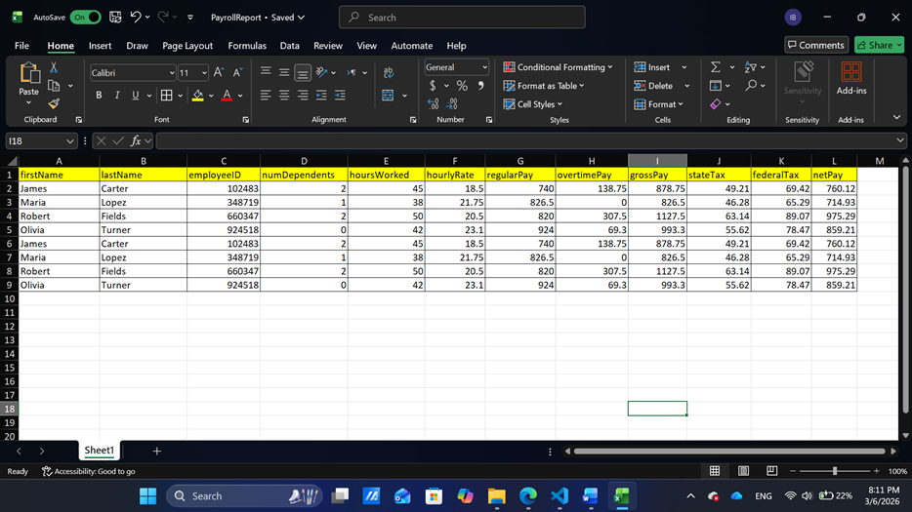

Debugging Summary

During testing, I identified and resolved several issues:
- pytest not recognized
  - Cause: Virtual environment not activated
  - Fix: Activated .venv correctly
- pandas not installed
  - Cause: New venv missing dependencies
  - Fix: Installed pandas and openpyxl
- Employee not found errors
  - Cause: Incorrect IDs in Excel
  - Fix: Verified and corrected EmployeeTable.xlsx
- Validation logic adjustments
  - Fixed name length rules
  - Fixed ID length rules
  - Fixed hours range
After debugging, all unit and integration tests passed successfully.

Testing Results Summary

Test Case | Result
Valid employee | PASS
Invalid hours | PASS
Invalid ID | PASS
Employee not found | PASS
Invalid first name | PASS
Integration workflow | PASS

Final Program Code (Python Implementation)

import pandas as pd

# Load employee database
employee_db = pd.read_excel("EmployeeTable.xlsx")

# Constants
REG_HOURS = 40
OT_MULT = 1.5
STATE_TAX_RATE = 0.056
FED_TAX_RATE = 0.079

# -----------------------------
# Security Module
# -----------------------------
def SecurityModule(firstName, lastName, employeeID, numDependents, hoursWorked):
if not firstName or not lastName or not employeeID or numDependents == "" or hoursWorked == "":
return False, "Blank value detected. All values must be entered."

try:
hoursWorked = float(hoursWorked)
if hoursWorked < 1 or hoursWorked > 80:
return False, "Hours worked must be between 1 and 80."
except:
return False, "Hours worked must be numeric."

try:
numDependents = int(numDependents)
if numDependents < 0 or numDependents > 10:
return False, "Number of dependents must be between 0 and 10."
except:
return False, "Dependents must be numeric."

if not employeeID.isdigit() or len(employeeID) != 6:
return False, "Employee ID is 6 digits long."

if not firstName.isalpha() or len(firstName) < 2 or len(firstName) > 20:
return False, "That is not a valid first name."

if not lastName.isalpha() or len(lastName) < 2 or len(lastName) > 20:
return False, "That is not a valid last name."

return True, ""

# -----------------------------
# Get Hourly Rate Module
# -----------------------------
def GetHourlyRateFromDatabase(employeeID):
match = employee_db[employee_db["employeeID"] == int(employeeID)]
if match.empty:
return 0, False
return float(match["hourlyRate"].iloc[0]), True

# -----------------------------
# Pay Calculation Module
# -----------------------------
def PayCalculationModule(employeeID, hoursWorked):
hourlyRate, rateFound = GetHourlyRateFromDatabase(employeeID)
if not rateFound:
return None, False

hoursWorked = float(hoursWorked)

if hoursWorked <= REG_HOURS:
regularHours = hoursWorked
overtimeHours = 0
else:
overtimeHours = hoursWorked - REG_HOURS
regularHours = REG_HOURS

regularPay = round(regularHours * hourlyRate, 2)
overtimePay = round(overtimeHours * hourlyRate * OT_MULT, 2)
grossPay = round(regularPay + overtimePay, 2)

stateTax = round(grossPay * STATE_TAX_RATE, 2)
federalTax = round(grossPay * FED_TAX_RATE, 2)
netPay = round(grossPay - stateTax - federalTax, 2)

return {
"hourlyRate": hourlyRate,
"regularHours": regularHours,
"overtimeHours": overtimeHours,
"regularPay": regularPay,
"overtimePay": overtimePay,
"grossPay": grossPay,
"stateTax": stateTax,
"federalTax": federalTax,
"netPay": netPay
}, True

# -----------------------------
# Write Results to Excel
# -----------------------------
def WriteToExcel(test, result):
try:
df = pd.read_excel("PayrollReport.xlsx")
except:
df = pd.DataFrame(columns=[
"firstName", "lastName", "employeeID", "numDependents", "hoursWorked",
"hourlyRate", "regularPay", "overtimePay", "grossPay",
"stateTax", "federalTax", "netPay"
])

new_row = {
"firstName": test["firstName"],
"lastName": test["lastName"],
"employeeID": test["employeeID"],
"numDependents": test["numDependents"],
"hoursWorked": test["hoursWorked"],
"hourlyRate": result["hourlyRate"],
"regularPay": result["regularPay"],
"overtimePay": result["overtimePay"],
"grossPay": result["grossPay"],
"stateTax": result["stateTax"],
"federalTax": result["federalTax"],
"netPay": result["netPay"]
}

df = pd.concat([df, pd.DataFrame([new_row])], ignore_index=True)
df.to_excel("PayrollReport.xlsx", index=False)

# -----------------------------
# TEST CASES
# -----------------------------
test_cases = [
{
"name": "Valid employee with overtime",
"firstName": "James",
"lastName": "Carter",
"employeeID": "102483",
"numDependents": 2,
"hoursWorked": 45
},
{
"name": "Invalid hours (too high)",
"firstName": "Maria",
"lastName": "Lopez",
"employeeID": "348719",
"numDependents": 1,
"hoursWorked": 100
},
{
"name": "Invalid employee ID length",
"firstName": "Daniel",
"lastName": "Hughes",
"employeeID": "7712",
"numDependents": 3,
"hoursWorked": 40
},
{
"name": "Employee not found",
"firstName": "Ashley",
"lastName": "Bennett",
"employeeID": "999999",
"numDependents": 0,
"hoursWorked": 40
},
{
"name": "Invalid first name",
"firstName": "A",
"lastName": "Fields",
"employeeID": "660347",
"numDependents": 2,
"hoursWorked": 40
},
{
"name": "Valid employee - Maria",
"firstName": "Maria",
"lastName": "Lopez",
"employeeID": "348719",
"numDependents": 1,
"hoursWorked": 38
},
{
"name": "Valid employee - Robert",
"firstName": "Robert",
"lastName": "Fields",
"employeeID": "660347",
"numDependents": 2,
"hoursWorked": 50
},
{
"name": "Valid employee - Olivia",
"firstName": "Olivia",
"lastName": "Turner",
"employeeID": "924518",
"numDependents": 0,
"hoursWorked": 42
}

]

# -----------------------------
# Test Runner
# -----------------------------
def run_test(test):
print("\n---", test["name"], "---")

valid, msg = SecurityModule(
test["firstName"],
test["lastName"],
test["employeeID"],
test["numDependents"],
test["hoursWorked"]
)

if not valid:
print("SecurityModule FAILED:", msg)
return

result, found = PayCalculationModule(test["employeeID"], test["hoursWorked"])
if not found:
print("Employee not found in database.")
return

print("PayCalculationModule PASSED")
print(result)

WriteToExcel(test, result)
print("Saved to PayrollReport.xlsx")

# -----------------------------
# Run all tests
# -----------------------------
for t in test_cases:
run_test(t)

DataBases
EmployeeTable:
EmployeeTable

PayrollReport:
PayrollReport

